Ex.no:2 | EDA-DATA IMPORT AND EXPORT
Date:

Aim:
To inspect dataset features, detect null values, and export data into CSV, Excel, and SQLite database formats.
Algorithm:
- Import pandas and sqlite3 libraries.
- Sales data.xlsx using pd.read_excel().
- Inspect data structure using .head(), .tail(), .info(), .describe(), and .isnull().sum().
- Export DataFrame to .csv and .xlsx formats using .to_csv() and .to_excel().
- Connect to sales data.db using sqlite3 and write data into an SQL table via .to_sql().
- Close the database connection and end execution.
Program:
# Import required libraries
import pandas as pd

# Load the Sales dataset
df=pd.read_excel("C:/Users/ramya/Downloads/Sales data.xlsx")

# Display the complete dataset
print("===== DATASET =====")
print(df)

# Display first five records
print("\n===== FIRST FIVE ROWS =====")
print(df.head())

# Display last five records
print("\n===== LAST FIVE ROWS =====")
print(df.tail())

# Display dataset information
print("\n===== DATASET INFORMATION =====")
print(df.info())

# Display statistical summary
print("\n===== STATISTICAL SUMMARY =====")
print(df.describe(include='all'))

# Display dataset shape
print("\nDataset Shape:", df.shape)

# Display column names
print("\nColumns:")
print(df.columns)

# Check missing values
print("\n===== MISSING VALUES =====")
print(df.isnull().sum())

# Export dataset to Excel
df = pd.read_excel("C:/Users/ramya/Downloads/Sales data.xlsx")
df.to_csv("C:/Users/ramya/Downloads/sales.csv", index=False)
print("CSV file created successfully")

import sqlite3

# Create SQLite database
df=pd.read_excel("C:/Users/ramya/Downloads/Sales data.xlsx")
conn=sqlite3.connect("C:/Users/ramya/Downloads/Sales data.db")

# Export DataFrame to SQL table
df.to_sql("archive_data",conn,if_exists="replace",index=False)
print("Data imported into SQL successfully")
query="SELECT * FROM archive_data"
df_sql=pd.read_sql(query, conn)
print(df_sql.head())
# Export dataset to Url
url="C:/Users/ramya/Downloads/Sales data.xlsx"
df=pd.read_excel(url)
df.head()
# Exported into JSON file
df=pd.read_csv("C:/Users/ramya/Downloads/sales data.xlsx")
df.to_json("Amazon_output.json",orient="records")
print("JSON File Exported")

Output:

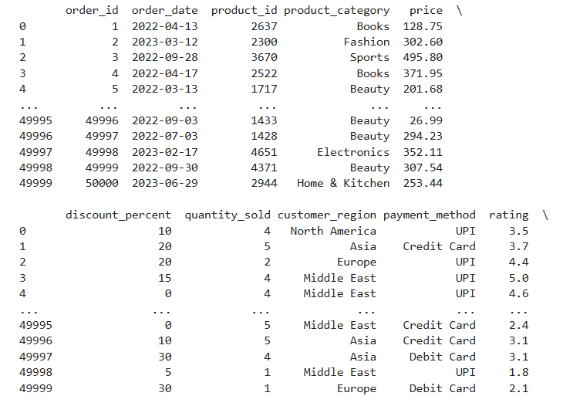
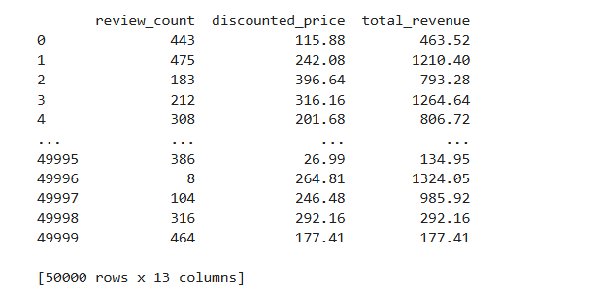

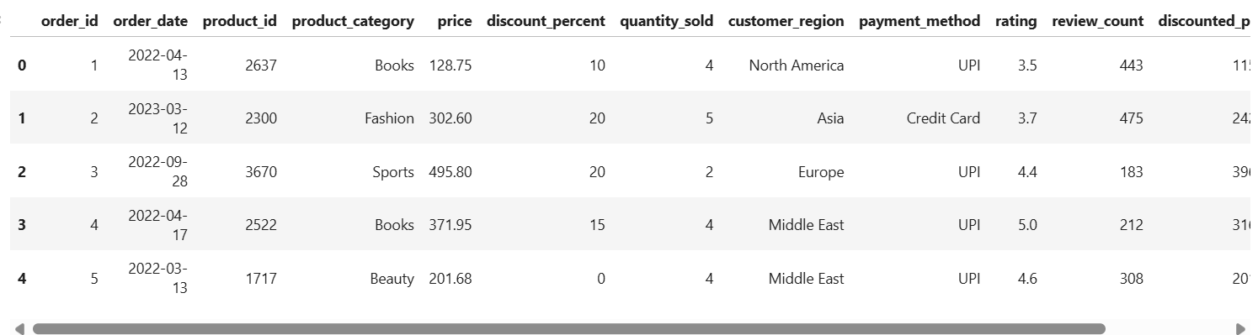
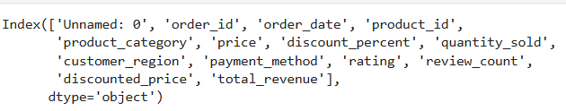
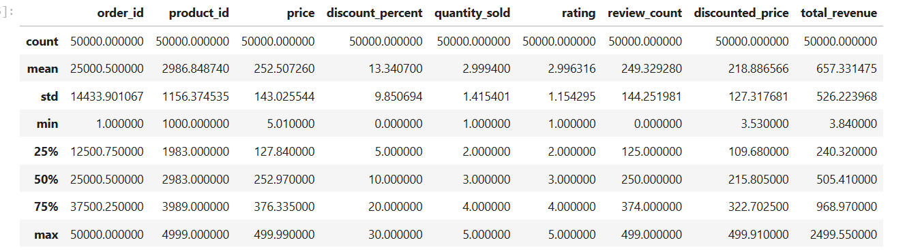

Result:

